
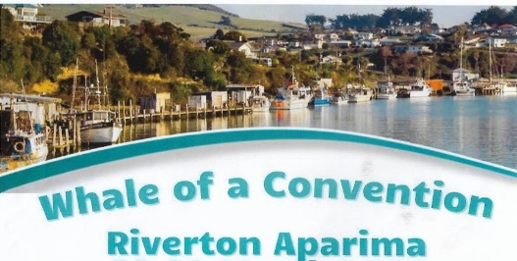
202F District Convention
21st – 22rd March
Venue: Riverton RSA
Palmerston St Riverton

REGISTRATION FORM
Note: An online version of this form is available here

IMPORTANT: Each LION must complete a separate registration form (please print clearly)

Surname |  |  |  |  |  |  |  | First Name
Club |  |  |  |  |  |  |  | District
Lion |  |  |  | Leo |  |  |  | Office Held
Partner’s Surname |  |  |  |  |  |  |  | First Name
Postal Address
 |  |  |  |  |  |  |  |  |  | Post Code
Email |  |  |  |  |  |  |  |  |  | Phone
REGISTRATION AND FUNCTIONS |  |  |  |  |  |  |  |  |  | COST ($) |  | LION | PARTNER |  | TOTAL ($)
Convention Registration: Lion (Compulsory/non-refundable) |  |  |  |  |  |  |  |  |  | $40.00 |  |  | N/A
Convention Registration: Non-Lion Partner |  |  |  |  |  |  |  |  |  |  |  | N/A
Friday Night Early registration |  |  |  |  |  |  |  |  |  | $0.00 |  | -
Saturday Morning tea and lunch |  |  |  |  |  |  |  |  |  | $30.00 |  |  | N/A
Partner’s Tour includes Morning tea and lunch |  |  |  |  |  |  |  |  |  | $50.00
Saturday Evening meal, entertainment, and live music |  |  |  |  |  |  |  |  |  | $80.00
Sunday Rededication/Remembrance Service with light lunch |  |  |  |  |  |  |  |  |  | $25.00
Raffle tickets 3 for $5.00 |  |  |  |  |  |  |  |  |  | $5.00
Convention Badge |  |  |  |  |  |  |  |  |  | $10.00
$ TOTAL TO PAY $
Dietary Requirements
Gluten Free |  |  |  |  | Vegetarian |  |  |  | Dairy Free |  |  | Other |  | ?

REGISTRATIONS CLOSE 28th February 2026
Payment is by way of Internet Banking.
Account Name: Lions Club of Riverton
Account Number: 060954-0033305-01
Details: Code: Lions Name Reference : Registration

Particulars: Member’s Name: Code: Club Name Reference: Registration

Date Internet Banking Completed: ___/___/______ (D/M/Y)
(Registrations will be confirmed once the internet banking is received)
POST: Lions 202F Convention, 202f.convrego@lionsclubs.org.nz
Or 51 Marne st Riverton Aparima 9822

POST: Lions 20 for 2F Convention, C/- Olivia Montgomery 8

